Cruise Report

Eco-FOCI Fall Moorings

Cruise DY17-08

NOAA ship Oscar Dyson

September 22 – October 7, 2017

Geoff Lebon
Matt Wilson
Nissa Ferm
Peter Proctor
Stephanie Grassia
Tanika Ladd

Scientific Staff
Geoff Lebon PMEL/FOCI/JISAO
Peter Proctor PMEL/FOCI/JISAO
Matt Wilson ASFC/FOCI
Nissa Ferm AFSC/FOCI/Lynker Technologies
Stephanie Grassia AFSC/MML/JISAO
Dan Langis PMEL/FOCI/NOAA Corps
Molly Semones Ohio Sea Grant/Ohio St Univ
Kerri Seger Univ of New Hampshire
Tanika Ladd Univ of California Santa Barbara

Cruise Objective
The primary objective of cruise DY17-08 was the recovery of the surface moorings at M2 followed by the turnaround of moorings at sites M4, M5, and M8. The CTD/Bongo boxes around each of these sites followed by the marine mammal mooring turnarounds and the 72 m isobaths were next in line. The lowest priority was the Unimak box and the DBO1 line.

An added objective was the recovery of the Bogoslof acoustic mooring if time permitted.

Operations
The operations consisted of 4 main categories, moorings, ctd’s, bongo/CalVET tows, and marine mammal ops.

1) Moorings and glider, Geoff Lebon:

Mooring operations for DY17-8 consisted of 14 moorings recovered and 17 moorings deployed. These included 4 ADCP (Acoustic Doppler Current Profiler) moorings turned around, 4 passive acoustic moorings turned around, 3 physical oceanographic moorings turned around and one deployed, 5 ice popup moorings deployed, 2 surface moorings recovered, and one geological acoustic mooring recovered. All mooring operations were performed without incident or damage to any instrumentation. One passive acoustic mooring had to be recovered by dragging as the release failed to operate properly. A complete list of all instruments attached to each mooring is listed in the tables below.

The Oculus glider was recovered at the M4 site after completion of the M4 moorings. Weather was such that the glider was recovered from the Dyson’s small boat which facilitated a successful recovery.

Moorings recovered, ADCP = Acoustic Doppler Current Profiler; Eco; SeaCat=conductivity, temperature, depth; MicroCat=conductivity, temperature, depth; Optode=oxygen sensor; SBETemp=temperature sensor; AURAL=passive acoustics; AWCP=fish finder; PAL=passive acoustics; CPOD=echolocation.
Mooring | ADCP | Current Meter |  | MTR | Sea Cat |  | Optode | SBE Temp | pCO2 pH
 |  |  | Eco |  |  | Micro Cat |  |  |  | AURAL | AWCP PAL CPOD | Haru Phone
16BSP4A | 1 |  |  |  |  |  |  |  |  | 1
16BS4B |  |  | 1 | 10 | 1 | 3 | 1 | 5
16BSP5A | 1 |  |  |  |  |  |  |  |  | 1 | 1
16BS5A |  |  | 1 |  |  | 3 |  | 9
16BSP8A | 1 |  |  |  |  |  |  |  |  | 1
16BS8A |  |  | 1 |  | 2 | 2 |  | 2 | 1
17BSM2A |  | 1 | 4 | 4 | 3 | 4 | 1 | 9 | 1
17BSP2A | 1 |  |  |  | 1 |  |  |  | 1 | 1
17BS-ITAE |  |  | 2 |  |  |  | 2 | 1
AL16_AU_BS1 |  |  |  |  |  |  |  |  |  | 1
AL16_AU_BS2 |  |  |  |  |  |  |  |  |  | 1
AL16_AU_BS3 |  |  |  |  |  |  |  |  |  | 1
AL16_AU_BS4 |  |  |  |  |  |  |  |  |  | 1
Bogoslof |  |  |  |  |  |  |  |  |  |  |  | 1

Moorings deployed, ADCP = Acoustic Doppler Current Profiler; Eco; SeaCat=conductivity, temperature, depth; MicroCat=conductivity, temperature, depth; Optode=oxygen sensor, SBE Temp=temperature sensor; AURAL=passive acoustics; AWCP=fish finder; PAL=passive acoustics; CPOD=echolocation.
Mooring | ADCP | Current Meter | Eco |  | MTR | Sea Cat | Micro Cat | Optode |  | pCO2pH
 |  |  |  |  |  |  |  |  | SBE Temp |  | AURAL | AWCP PAL CPOD | Pop up buoys
17BS2C |  | 1 |  | 2 |  | 2 | 3 | 1 | 7 | 1
17BSP2B | 1 |  |  |  |  |  |  |  |  |  | 1 | 1
17BS4B |  |  |  | 1 | 10 | 1 | 3 |  | 5
17BSP4A | 1 |  |  |  |  |  |  |  |  |  | 1
17BS5A |  |  |  | 1 |  |  | 3 |  | 9
17BSP5A | 1 |  |  |  |  |  |  |  |  |  | 1 | 1
17BS8A
17BSP8A | 1 |  |  | 1 |  | 2 | 2 |  | 8 | 1 | 1
AL17_AU_BS1 |  |  |  |  |  |  |  |  |  |  | 1
AL17_AU_BS2 |  |  |  |  |  |  |  |  |  |  | 1
AL17_AU_BS3 |  |  |  |  |  |  |  |  |  |  | 1
AL17_AU_BS4 |  |  |  |  |  |  |  |  |  |  | 1
St Mathew Is |  |  |  |  |  |  |  |  |  |  |  |  | 5

2) CTDs, Peter Proctor, Tanika Ladd:

CTDs were performed along the 72m isobath from the M2 mooring site up to the M8 mooring site to continue long term monitoring of the Bering Sea Ecosystem. Every other station between mooring sites was occupied with a CTD to coincide with all bongo tow stations. In addition, all stations around each mooring site comprising the box at each site was occupied. At the Unimak box, all stations were occupied with a CTD cast along with the four marine mammal Aural stations that were positioned east of the 72-m isobath and in Unimak Pass. The table below summarizes the samples taken at each CTD station but does not include the coccolithophore sampling.

The main goal of the coccolithophore project is to gain insight into the role of coccolithophores, especially Emiliania huxleyi, in the Bering Sea ecosystem and to shed light on the causes and consequences of blooms of E. huxleyi. Sampling for the coccolithophore project occurred at a subset of the 70m isobath stations, the mooring box stations, and the Unimak box stations (see below for list of stations sampled). At each station, samples were taken for RNA, DNA, Particulate organic carbon, nitrogen and phosphorous, particulate inorganic carbon (CaCO3), phytoplankton community composition (by light microscopy and flow cytometry), and coccolithophore identification and morphology (by scanning electron microscopy). These samples were collected and pre-filtered at different sizes to target and compare two size classes of phytoplankton, nanophytoplankton (2-20µm – includes E. huxleyi, bloom forming coccolithophore) and microphytoplankon (20-200µm).
Stations sampled (13 total, station number/site name):
Sta11/70m14, Sta13/70m18, Sta18/M4W, Sta24/70m34, Sta26/M5S, Sta31/70m40, Sta35/70m55,
Sta39/M8N, Sta42/70m52, Sta45/70m46, Sta51/UBW4, Sta54/UBW1, and Sta66/UBE1

Summary of all CTD Sampling for Cruise DY17-08
CTD # | Site | Station Number | No. of Nutrients | Salinity Samples | Oxygen Samples | Chlorophyll Samples | Number of DIC | DOP/DON Sample Number | J. Gann Depths | UAF-CO2
CTD001 | M2C | 1 | 6 | 1 | 1 | 8 |  |  |  | 1
CTD002 | M2C | 1 | 6 |  | 1 | 8 |  |  |  | 1
CTD003 | M2W | 2 | 7 |  | 1 | 6 |  | 811
CTD004 | M2S | 3 | 7 | 1 | 1 | 6 |  | 812
CTD005 | M2E | 4 | 7 |  | 1 | 6 |  | 813
CTD006 | M2N | 5 | 7 | 1 | 1 | 6 |  | 814
CTD007 | 70M4 | 6 | 7 |  | 1 | 6 |  | 815
CTD008 | 70M6 | 7 | 7 |  | 1 | 6 | 2 | 816 | 0/30
CTD009 | 70M8 | 8 | 7 | 1 | 1 | 6 |  | 817
CTD010 | 70M10 | 9 | 7 |  | 1 | 6 | 2 | 818 | 0/30
CTD011 | 70M12 | 10 | 7 |  | 1 | 6 |  | 819
CTD012 | 70M14 | 11 | 7 | 1 | 1 | 6 | 2 | 820 | 0/20
CTD013 | 70M16 | 12 | 7 |  | 1 | 6 |  | 821
CTD014 | 70M18 | 13 | 7 |  | 1 | 6 | 3 | 822
CTD015 | 70M18/M4S | 14 | 7 |  | 1 | 6 |  | 823
CTD016 | M4E | 15 | 7 | 1 | 1 | 6 |  | 824
CTD017 | M4C | 16 | 8 |  | 1 | 9
CTD018 | M4C | 16 | 8 |  | 1 | 9 | 2 | 825 | 0/20
CTD019 | M4N | 17 | 7 | 1 | 1 | 6 |  | 826
CTD020 | M4W | 18 | 7 |  | 1 | 6 |  | 827
CTD021 | 70M24 | 19 | 7 |  | 1 | 6 | 2 | 828 | 0/20
CTD022 | 70M26 | 20 | 7 |  | 1 | 6 |  | 829
CTD023 | 70M28 | 21 | 7 | 1 | 1 | 6 | 3 | 830 | 0/30
CTD024 | 70M30 | 22 | 7 |  | 1 | 6 |  | 831
CTD025 | 70M32 | 23 | 7 |  | 1 | 6 | 2 | 832 | 0/20
CTD026 | 70M34 | 24 | 7 |  | 1 | 6 |  | 833
CTD027 | 70M36 | 25 | 7 | 1 | 1 | 6 | 3 | 834 | 0/30
CTD028 | M5S | 26 | 7 |  | 1 | 6 |  | 835
CTD029 | M5E | 27 | 7 |  | 1 | 6 |  | 836
CTD030 | M5C | 28 | 8 |  |  | 9 |  | 837?
CTD031 | M5C | 28 | 8 |  | 1 | 9 |  | 838
CTD032 | M5N | 29 | 7 | 1 | 1 | 6 |  | 839
CTD033 | M5W | 30 | 7 |  | 1 | 6 |  | 840
CTD034 | 70M40 | 31 | 7 |  | 1 | 6 |  | 841
CTD035 | 70M42 | 32 | 7 |  | 1 | 6 | 2 | 842 | 0/30
CTD036 | AL17 AU BS1 | 33
CTD037 | 70M54 | 34 | 7 | 1 | 1 | 6 | 2 | 843 | 0/30
CTD038 | 70M55 | 35 | 7 |  |  | 6 |  | 844
CTD039 | M8S | 36 | 7 |  | 1 | 6 |  | 845
CTD040 | 70M56 | 37 | 7 |  |  | 6 |  | 846
CTD041 | M8W | 38 | 7 | 1 |  | 6 |  | 847
CTD042 | M8N | 39 | 7 |  | 1 | 6 |  | 848
CTD043 | M8E | 40 | 7 |  |  | 6 |  | 849
CTD044 | M8C | 41 | 1 | 1 |  | 9 |  |  |  | 2
CTD045 | M8C | 41 | 8 |  | 1 | 6 | 2 | 850 | 0/30 | 1
CTD046 | 70M52 | 42 | 7 |  |  | 6 |  | 851
CTD047 | 70M50 | 43 | 7 |  | 1 | 6 | 2 | 852 | 0/30
CTD048 | 70M48 | 44 | 7 | 1 |  | 6 |  | 853
CTD049 | 70M46 | 45 | 7 |  | 1 | 6 |  | 854 | 0/20
CTD050 | 70M44 | 46 | 7 |  |  | 6 |  | 855
CTD051 | 70M42 | 47 | 7 | 1 |  | 6
CTD052 | AL17 AU BS2 | 48 |  | 1
CTD053 | AL17 AU BS3 | 49
CTD054 | 70M2/M2C | 50 | 5 |  | 1 | 6 | 2 | 856 | 0/23 | 1
CTD055 | 70M2/M2C | 50 | 2 |  |  | 4 |  |  |  | 1
CTD056 | UBW4 | 51 | 10 |  |  | 6 | 3 | 857 | 0/30
CTD058 | UBW3 | 52 | 11 |  |  | 6
CTD058 | UBW2 | 53 | 11 |  |  | 6
CTD059 | UBW1 | 54 | 11 |  |  | 6 |  | 858
CTD060 | UBS4 | 55 | 10 |  |  | 6 |  | 859
CTD061 | UBS3 | 56 | 10 |  | 1 | 6 |  | 860
CTD062 | UBS2 | 57 | 9 |  |  | 6 |  | 861
CTD063 | UBS1 | 58 | 5 | 5 |  | 5 |  | 862
CTD064 | AL17 AU BS4 | 59
CTD065 | UBN1 | 60 | 10 |  |  | 6 |  | 863
CTD066 | UBN2 | 61 | 9 |  |  | 6 |  | 864
CTD067 | UBN3 | 62 | 9 |  |  | 6 |  | 865/868
CTD068 | UBN4 | 63 | 9 | 1 |  | 6
CTD069 | UBN5 | 64 | 9 |  |  | 6 |  | 869
CTD070 | UBN6 | 65 | 8 |  |  | 6 | 3 | 870/874 | 0/10
CTD071 | UBE1 | 66 | 8 |  | 1 | 6 |  | 875
CTD072 | UBE2 | 67 | 7 | 1 |  | 6
CTD073 | UBE3 | 68 | 6 |  |  | 6 | 2 | 880/882 | 0/10
Totals |  |  | 506 |  | 43 | 430 | 37

3) Bongo/CalVET tows, Matt Wilson, NIssa Ferm:

Zooplankton samples and water profiler data were collected simultaneously at 57 sites. These sites were along the 70-m isobath (25 sites), at and around the M2, M4, M5, and M8 moorings (20 sites), and along the Unimak Box (12 sites) (Fig. 1). At each site, a bongo-profiler array was used to sample from the sea surface to 10 m off bottom, or to 300 m depth, whichever was shallowest. Samples were collected with a 20-cm bongo (153-µm mesh) and a 60-cm bongo (505-µm mesh) net on the wire just below a Sea-Bird Electronics Fastcat profiler (SBE-49). The profiler was used to indicate net depth in real time, and to provide information on water properties (e.g., Fig. 1). Net 1 of each bongo net was typically preserved (5% formalin-buffered seawater solution) for quantitative analysis. Net 2 of each bongo was used for Rapid Zooplankton Assessment (RZA, RCountZ) of the geographic distribution of major zooplankton abundance. Geographic distribution of four key taxa are shown in Figure 2. The RZA was conducted at 32 bongo stations, summary statistics for each category are provided in Table 1. At each of the four “M” mooring sites, a California Vertical Egg Tow (CalVET) net (53-µm mesh) was used, along with the profiler, to collect triplicate samples of microzooplankton from the upper 60 m of the water column. The statistics and summary of these operations are provided in tables 2 and 3, respectively. Included in these tables are the 74 CTD casts conducted to collect high-resolution temperature and salinity data, and measure additional water properties (fluorescence, light, dissolved oxygen). Of these, 70 casts also were conducted to collect water samples for measurement of nutrients (Nut) and phytoplankton (PhytoF), and for instrument calibration (oxygen, chlorophyll, salinity)
Figure 1. Sampling and mooring site locations and water temperatures during DY17-08. Numerical labels indicate station number, which is repeated for successive sampling events (i.e., hauls) at the same site. Water temperature at the sea surface (1 db pressure, top panel) and at the maximum depth (db Max) as measured by the Fastcat (SBE-49) (note the different temperature scale for the Unimak Box inset).
Figure 2: DY17-08 estimates of abundance of four key taxa groups of the rapid zooplankton assessment. Scales are different for each map, an “x” indicates zero. 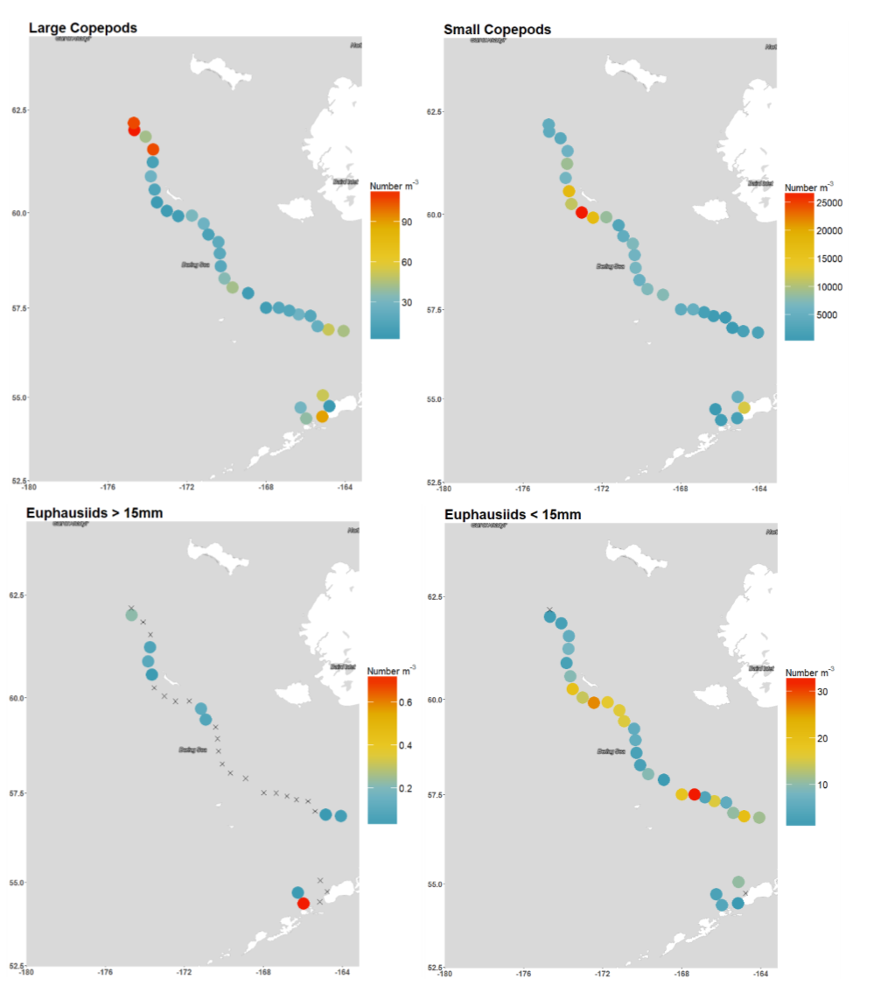

Table 1. DY17-08 summary statistics from the Rapid Zooplankton Assessment. Taxa are ranked from highest to lowest abundance (m³). Copepods are separated into those smaller than 2 mm and those larger.

Zooplankton Type | Mean | SE | Min | Max
Small copepods | 6296.96 | 1004.21 | 482.37 | 26506
Other small zooplankton | 100.92 | 25.08 | 0 | 502.65
Large copepods | 33.61 | 5.38 | 4.73 | 114.9
Chaetognaths | 27.29 | 4.28 | 0 | 125.01
Shelled Pteropods | 10.18 | 5.36 | 0 | 158.23
Euphausiids < 15mm | 9.47 | 1.44 | 0 | 32.44
Other large zooplankton | 3.24 | 1.55 | 0 | 43.78
Decapods | 2.84 | 1.8 | 0 | 54.02
Amphipods | 0.54 | 0.15 | 0 | 2.96
Non-shelled Pteropods | 0.07 | 0.03 | 0 | 0.81
Euphausiids > 15mm | 0.04 | 0.02 | 0 | 0.73

Table 2. DY17-08 statistics from sampling with bongo and CalVET nets, the SBE-49 (fastcat), and CTD casts with (CTDB) and without bottles (CTD).

Cruise Statistics for FOCI Cruise DY17-08

Gears Used Tows
20BON - 20 cm bongo 57
60BON - 60 cm bongo 57
CalVET - CalCOFI vertical egg tow net 12
CAT – Seabird SeaCAT CTD 69

4) Passive Acoustics Marine Mammal Ops, Stephanie Grassia
During the fall Dyson Cruise, eight AURAL (Autonomous Underwater Recorder for Acoustic Listening) recorders where retrieved and deployed. Four of the AURALs occupy space on the short PMEL moorings along the 70m isobaths and four AURALs are located on independent marine mammal lab moorings located along the 50m isobaths.
Over the course of the cruise a total of 54 sonobuoys were deployed with a 90.7% (49/54) success rate. Roughly 61 hours of data were monitored and recorded. Fin whales were heard on 53.1% of the sonobuoys (26 buoys), humpback whales on 6.1% (3 buoys), killer whales on 2.0% (1 buoy), and possible pinniped on 8.2% (4 buoys).

Summary: The Dyson left Dutch Harbor on September 22nd vs the scheduled September 21st due to the shipment of supplies needed for the cruise arriving late. After completion of loading and securing of all equipment, the Dyson headed for the M2 mooring site.
Upon arrival at the M2 site, the Dyson proceeded to recover the Surface Peggy and ITAE Moorings. Weather and darkness deemed that the Dyson should continue up the 70-m isobath before finishing the M2 mooring work. The Dyson then continued up the 70-m isobath to the M4 site with the goal of recovering the Oculus glider on September 26th which was a critical date due to low battery power for the glider. The M4 mooring work was completed before picking up the glider and continuing up the isobath line to the M5 site.

Upon completion of the M5 mooring work, the Dyson headed to and finished the BS1 mooring site. This allowed the Dyson to complete all mooring ops during daylight while continuing to move along the path to turn around the M8 moorings and to finish the 70-m isobath stations.
Once the 70-m isobath was complete, the Dyson was able to turnaround the BS2 and BS3 mammal moorings and finish the rest of the M2 mooring operations. These were all able to be accomplished in daylight hours.

With the 70-m isobath complete and operations being ahead of schedule, The Dyson headed to Bogoslof Island to recover an acoustic mooring. This mooring was placed at the Island last spring to record the active volcanic eruption at Bogoslof Island and was a joint project of the USGS and the NOAA acoustic lab based in Newport. The mooring was recovered before the Unimak Box was started as the weather outlook was bleak and it was advantageous to finish work farther west first and then head east to occupy the Unimak Box and the mammal mooring BS4.

The Unimak Box was completed ahead of the approaching storm after which the ship headed to Kodiak, docking on October 7th.

The DBO 1 line was not occupied as a weather front was moving in and the USCG cutter Healy was able to occupy the line in mid-September. This was the only operation listed in the project instructions in addition to the occupation of the CTD only stations on the 70-m that was not carried out.

